POTRAZ Innovation Drive

#OpenChallenge1-2022

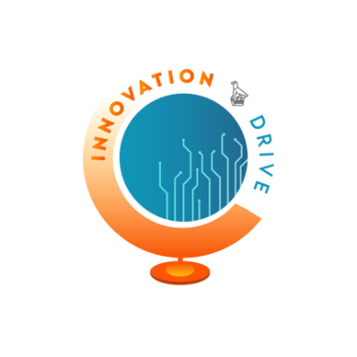

Thank you for your interest in the Innovation Drive “#OpenChallenge1". Please note the following:
- The Hackathon is open to all Zimbabweans who:
  - Are passionate about technology and innovation;
  - Have ideas or existing projects that makes use of ICTs to proffer solutions that improve the country’s socio-economic status;
  - Are individuals or a team of motivated people who would like to further develop their innovative idea or an existing project.
- There are two ways to participate:
  - Apply as an individual; or
  - Apply as a team of up to 5 participants.
- Those willing to participate in the Challenge must have completed their Application Forms, not later than 19 June 2022. Access to the form after this date will not be possible.
- A total of ZWL 175 million is available to implement the successful ideas with support from the Innovation Drive.
- Shortlisted applicants will be notified by 24 June 2022
- Please email all enquiries to innovationdrive@potraz.gov.zw.
- POTRAZ reserves the right to change the above stated dates or the format (virtual to physical).
- No transfer, grant or license of rights under any patent or copyright or to any intellectual property, proprietary information and/or trade secret is made or is to be implied by completing this application.
- Submit the completed application online at:
https://bit.ly/drivezw1
- Applications submitted via the Innovation Drive email will not be accepted.
People with special needs are highly encouraged to apply

PART I – APPLICANT INFORMATION
- Email Address
- Project Name
- Innovator/Team Name
- Full name of Applicant
- Gender
- Date of Birth
Example: January 7, 2019
- Highest Level of Education
- Main Language
- Do you have any of the following conditions that have lasted, or are likely to last, for six months or more?

(a) Sight problems not corrected by glasses or contact lenses
(b) Hearing problems
(c) Speech problems
(d) Blackouts, fits, or loss of consciousness
(e) Difficulty learning or understanding things
(f) Limited use of arms or fingers
(g) Difficulty gripping things
(h) Limited use of legs or feet
(i) Any condition that restricts physical activity or physical work (e.g. back problems, migraines)
(j) Any disfigurement or deformity
(k) Any mental illness for which help or supervision is required
(l) None of the above
Other:

- Are you part of a team?
- Specify number of team members
- Mailing (physical) address
- Email address
- Contact Number
- Province
- City, Town or Place

PART II – PROJECT DETAILS

- Project Summary

- Which of the following sectors does your project fall under?
  - Business, consultancy or management
  - Accountancy, banking or finance
  - Charity and voluntary work
  - Creative arts or design
  - Education
  - Energy and utilities
  - Engineering or manufacturing
  - Environment or agriculture
  - Healthcare
  - Hospitality or events
  - Computing or IT
  - Law
  - Law enforcement and security
  - Leisure, sport or tourism
  - Marketing, advertising or PR
  - Media or digital
  - Mining
  - Property or construction
  - Public services or administration
  - Recruitment or HR
  - Retail
  - Sales
  - Science or pharmaceuticals
  - Social care
  - Teacher training or education
  - Transport or logistics
  - Other:

- Problem Definition
What challenge / problem does the innovation address? In what way does the innovation make use of Information Communication Technologies (ICTs) to proffer sustainable solutions to improve the country’s socio-economic status? Define and quantify the target market for the innovation.

- Technological Impact
Clearly describe the impact of the innovation and the potential of the proposed idea to cause technological change/digital transformation. How are ICT concepts used in this Project? How is this Project different from what is currently available in the public domain? Is it a unique idea or a new way of doing something that is already being done? Indicate the easiness with which the innovation can be developed, and how fast it can be commercialised. Indicate how easy it is for the potential customers to deploy the innovation, taking into account time, change of behaviour and the speed of technological advancement.

- Sustainability
Describe how the innovation can turn into a project that can be sustained and the potential that the innovation can be scaled up to a national or international level.

- Revenue Generation Model
Describe how the innovation will generate revenue to sustain the livelihood of the innovator and create employment for other Zimbabweans.

- Previous Participation in the Innovation Drive
Have you participated in the POTRAZ Innovation Drive before? (Yes/No). If ‘Yes’, what was the outcome of your participation?

- Funding Requirements
Please provide an estimate of the funding requirements for the project in ZWL$.

- Other Grants/Loans awarded to the Applicant
Awarding Organisation | Description of Grants / Awards / Loans | Amount | Status (ongoing / completed)

- Project Team Members (Up to a maximum of 5)
Provide: Name, Gender (M/F), Age, WhatsApp Number, Local Calling Number, Next of Kin Contact Number, Email Address
 | Name | Gender  M/F | Age | WhatsApp Number | Local Calling Number | Next of Kin Contact Number | Email Address

Declaration
I declare that I am the originator of this idea, and that the information given by me in this application and any sheets attached hereto is true to the best of my knowledge and I have not wilfully suppressed any material fact. I accept that if any of the information given by me in this application is in any way false, or incorrect, the Authority shall have the right to disqualify me.

Name of Applicant
Signature
Date

